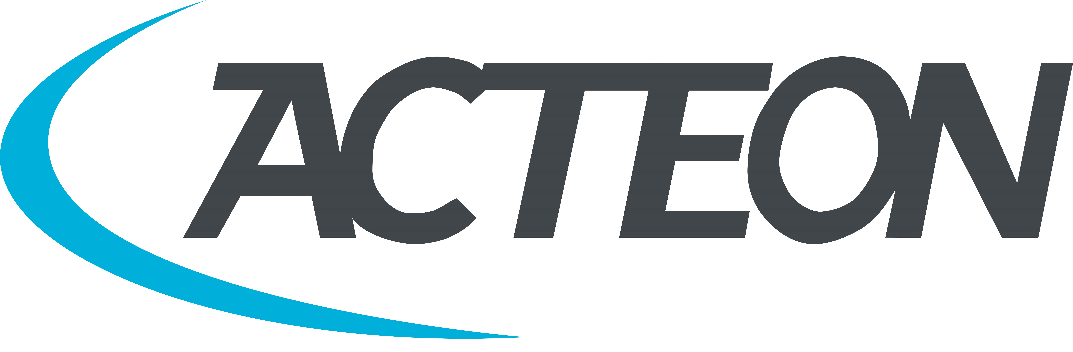
Acteon UK
www.acteongroup.com/uk-en/
Tel : 0800 038 9840

Acteon UK specialises in the manufacture and supply of innovative minimally invasive technologies for dental professionals, to help them implement efficient diagnosis, minimally invasive treatment and effective patient education.

The patient is at the forefront of everything we do, and we are a proud sponsor of the BSP. Together we are leading the way with our fight periodontal disease campaign in order to raise awareness of the links between periodontal and systemic disease.

As well as giving advice and producing patient information, we offer the following tools for effective periodontal treatment:

- The Soprocare camera detects plaque, calculus and gingival inflammation, eliminating the need to disclose and providing an instant image for the patient to see.
- Our Newtron scaling systems have patented technology and offer the most comprehensive range of tips in dentistry that can help practices implement minimally invasive cavity preparation, safe implant maintenance and extremely gentle prophylaxis that patients accept.
- The Air N Go low abrasive air polishing device switches from supra to sub easily and is designed to disrupt biofilm, remove stain and clean implants safely.

