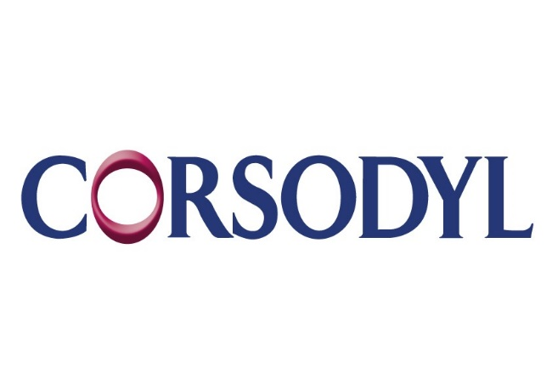
GSK
GSK Consumer Healthcare provides a range of specialist therapeutic oral care products which are clinically proven to help patients with oral health conditions such as: dentine hypersensitivity, gingivitis, erosive tooth wear and xerostomia. Our mission is to improve the quality of human life by enabling people to do more, feel better, live longer.
GSK proudly works closely with the BSP as one of their partner sponsors, helping to promote a better understanding of periodontitis and its impact on patients. Work this year included sponsorship of a series of webinars related to the new classification. In addition, an interactive lunch and learn module and distance learner CPD module were developed using a patient case study developed by the BSP and classification resources to drive practical implementation of the new guidance in general practice.

