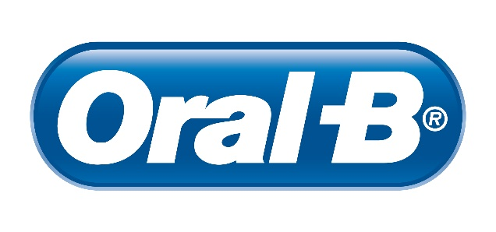
Oral B
Oral-B® is the worldwide leader in the over $5 billion brushing market. Part of the Procter & Gamble Company, the brand includes manual and electric toothbrushes for children and adults, oral irrigators and interdental products, such as dental floss.
Great technology is delivered through the Oral-B Genius X electric toothbrush in order to deliver optimum oral health. By combining motion sensor technology located in the brush, and video recognition using a smartphone’s camera, all areas of the user’s mouth can be tracked so that they know exactly where they’ve brushed and where they’ve missed. Patients receive instant feedback on the brushing of each zone of the mouth via the Oral-B App, including guidance on pressure applied and brushing duration.
The mechanical benefits of Oral-B’s electric toothbrushes compliment the chemical efficacy of the new Oral-B Gum & Enamel Repair Toothpaste which will help patients address the increasing prevalence of gum or enamel issues. With two sources of Stannous (Stannous Fluoride and Stannous Chloride), it is the best clinically-proven toothpaste from Oral-B to help restore gum health and prevent enamel erosion.
Oral-B works very closely with dental professionals and it is very proud to be one of the BSP partner sponsors.

